 ‘**Success for Everyone’**  Newsletter

**December 2023**

**Determination**

Interim Assistant Headteacher’s Message:

December is a time of reflection for the things past and anticipation for the new opportunities to come. As we approach the end of the Autumn Term I would like to give a vote of thanks to our learners for continuing to strive for success and to our parents and carers, for supporting us at EMLM this term. It is through collaboration and teamwork that we can keep our learners at the heart of everything that we do. I wish to thank our staff for their support and dedication in ensuring that our learners are given the tools to express their hopes and fears, continue to develop their resilience and determination and are allowed to be themselves in a safe and caring environment.

Many parents and carers may be thinking about ways to keep young people safe whilst using their devices. Please follow the link for a guide to keeping children safe online this Christmas. <http://www.skipseducational.org/>

Finally, school will finish on Wednesday 20th December 2023@ 2pm and reopen to our learners on 8th January 2024. I wish you all peace, comfort and joy and a

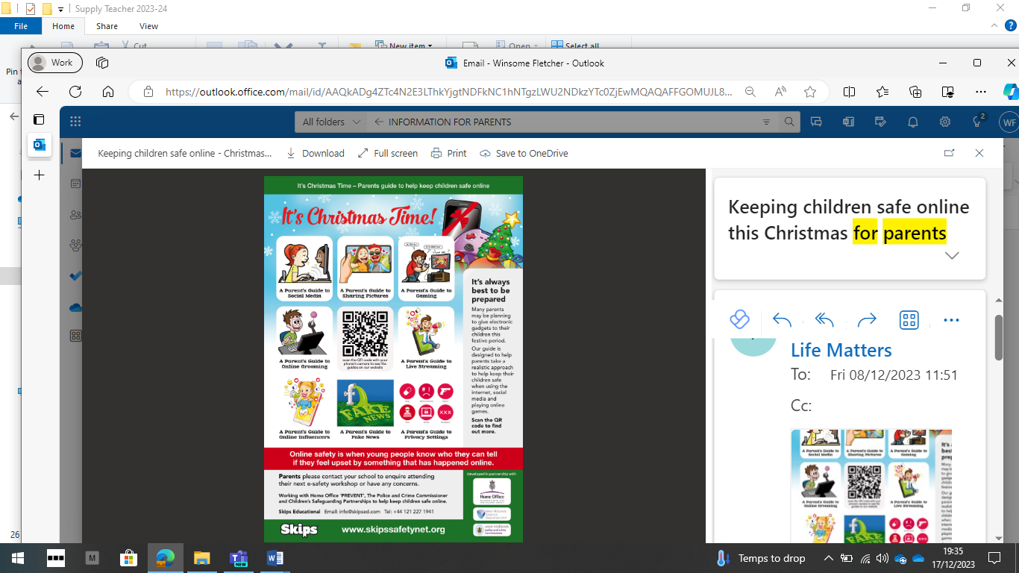

If you have any concerns or issues

please contact us on:

✆ 0208 698 9663

 Info@emlm.org.uk

**Merry Christmas and a Happy New Year 2024**

**Achievement Certificates this month have been given to learners for:**

*‘Working collaboratively with other learners.’ ‘Beginning to see self as a learner.’*

*‘Using the strategies taught to manage emotions.’ ‘Showing good behaviour for learning.*

*‘Showing a disciplined and mature attitude to learning.’ ‘Attending every day and on time.’*

*‘An improvement in timekeeping and being ready to start the day.’ ‘Showing resilience.’*



**🕘 Attendance - Late arrivals…**

Learners should arrive at school at 9:00am promptly.

**Registers close at 9:10am** and if you arrive after this time, your attendance will be marked as late!

**If you need support in arriving on time please speak to a member of staff.**

Pupil Voice: Alumni

It’s always a pleasure finding out about our previous learners, so many questions such as, how are they and what are they doing. Here is a little of what we found out:

*‘…doing very well. Enjoying going to college, punctuality not too bad!’ ‘…back in school now…will come to visit soon.’*

*‘…got my certificates and doing the course I wanted.’*

A parent could not resist joining in with:

*‘It’s like you’ve given me a million pounds…review a month ago - going well. Thank You!’*

**Parent/Carer consultations**

Our consultation meetings took place during the week 11th – 14th December, it was a very encouraging experience. We would like to thank all who were able to attend and the professionals who also contributed to the feedback and positive comments received: *C:‘Improved a lot, talking about work done in EMLM, attending every day.’ P1: ‘…more than capable, could do more.’ P2: ‘Speechless, proud of__ has changed a lot.’ SW: ‘Lots of good things nothing negative to say.’ P3: ‘…would like to acknowledge the level of work done, being here has bought __ out a lot.’ P4: Pleased to see work being done asked __ to explain the task.*

 Curriculum shout out: Religious Education

We live in a world where, for some, religion and faith have no lasting value. RE lessons help our learners to:

* learn about different religions, beliefs, values and traditions while exploring their own beliefs
* challenges them to consider and discuss issues of truth, belief, faith, ethics and questions of meaning
* Develop respect for, and sensitivity to, others (particularly, those whose faiths and beliefs are different from their own)
* Help combat prejudice

**KEY DATES**

***Date for your Diary***

*Monday 4th September 2023 School closed for Learners -staff training.*

**Autumn Term 1**

Tuesday 5th September

–

Friday 20th October 2023

**Half Term – EMLM closed**

Monday 23rd October

-

Friday 27th October 2023

**Autumn Term 2**

Monday 30 October

–

Wednesday 20th December 2023

**Christmas Holidays**

Thursday 21st December

-

Wednesday 3rd January 2024

INSET days:

Thursday 4th January 2024

Friday 5th January 2024

​

​

**Determination**

We are proud that learners at EMLM show such determination day in, day out.

When things go wrong, or sometimes, not as they expected them to, our learners are able to ask for help both from their peers and adults in school.

Staff encourage all our learners to take challenges and praise them for their effort when they’ve done their best, whether they have succeeded or not.

`

<https://communityconnectionslewisham.org/>

<https://lewisham.foodbank.org.uk/locations/>

<https://lewisham.gov.uk/myservices/environment/environment/energyefficiency>

<https://lewisham.gov.uk/myservices/cost-of-living/food-services>

**Online Safety**

All young adults regularly use different websites and apps from their parents, and it can be hard to keep up in this ever-changing digital world.

But the things that help keep children safe online are often similar to the things that keep them safe offline. It is important that we all continue to talk about what they think is normal online and what behaviour to expect from others and from themselves.

We encourage them to think critically and question what they see online. We ask them to consider where they go to get information they trust, talk about fake news, fake followers and scams. This will help them develop a healthy suspicion of whether people are who they say they are.

We have shown them how to report any worrying behaviour they see online – for example through [**Child Exploitation and Online Protection Command**](https://www.ceop.police.uk/safety-centre/) or the [**Internet Watch Foundation.**](https://www.iwf.org.uk/) ***Together we will prepare our children for their futures if we help them go online safely and responsibly.***

 **Postcards sent home for…**

*‘making the right choice.’*

*‘being focussed and ready to start working.’ ‘considering the feelings of others.’*

*‘taking part in an activity after initially not wanting to.’*

*‘completing spellings and mental maths test – well done!’*

*‘doing the right thing.’*

For sharing your opinion during the Values session.